ECA5802 IOE and AI Driven System
Gokulraj
192512002
Experiment 5(a): RFID/NFC-Based Device Identification & IoE Data Integration

To simulate and evaluate the performance of an RFID/NFC-based device identification system and integrate the resulting sensor data into an Internet of Everything (IoE) framework using Node-RED and the MQTT messaging protocol.

OBJECTIVES
Model the generation and transmission of RFID/NFC tag identifiers via a simulated publisher client.
Implement broker communication over dedicated MQTT topics (ioe/device/scan and ioe/device/cloud).
Process payload metadata through an edge reader function node to validate tag authentication and compute transmission latency.
Evaluate identification accuracy and communication throughput across authorized and unauthorized identification cards.

PROCEDURE
- Flow Environment Setup: Launch the Node-RED visual environment at http://localhost:1880/ and ensure the local/remote MQTT broker is initialized.
- Publisher Construction (MQTT Publisher Side):
Configure an Inject node labeled card to trigger device scan events.
Wire the trigger into a Function node labeled user to attach device metadata (e.g., tag_id, temperature).
Connect the output to an MQTT Out node configured to publish on the topic ioe/device/scan.
- Subscriber and Reader Processing (MQTT Receiver Side):
Add an MQTT In node subscribed to topic ioe/device/scan.
Wire the input into a Function node labeled reader to perform tag lookup, verify credentials, assign device ID, and compute latency_ms.
Route validated data into an MQTT Out node targeting ioe/device/cloud for cloud ingestion and a Debug node (debug 1) for real-time monitoring.
- Execution & Verification: Click Deploy, trigger sample scans for authenticated tags (RFID004, RFID002) and unregistered tags (UNKNOWN999), and log the debug payload stream.
CO1 Simulation • Experiment 5(a) Lab Manual Page 1 of 2
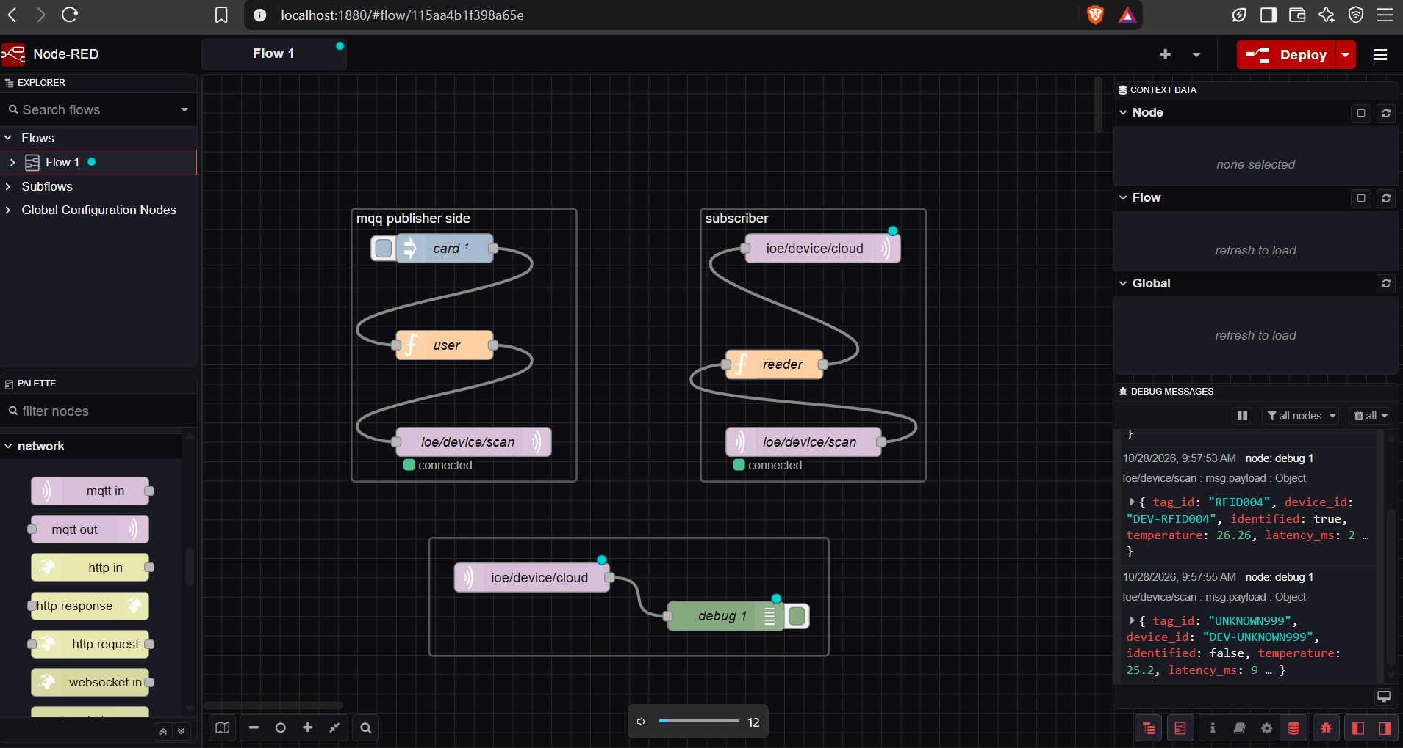
FLOW ARCHITECTURE & SYSTEM EXECUTION
Figure 1: Node-RED simulation canvas showing publisher pipeline, edge reader logic, cloud broker
integration, and debug messages.
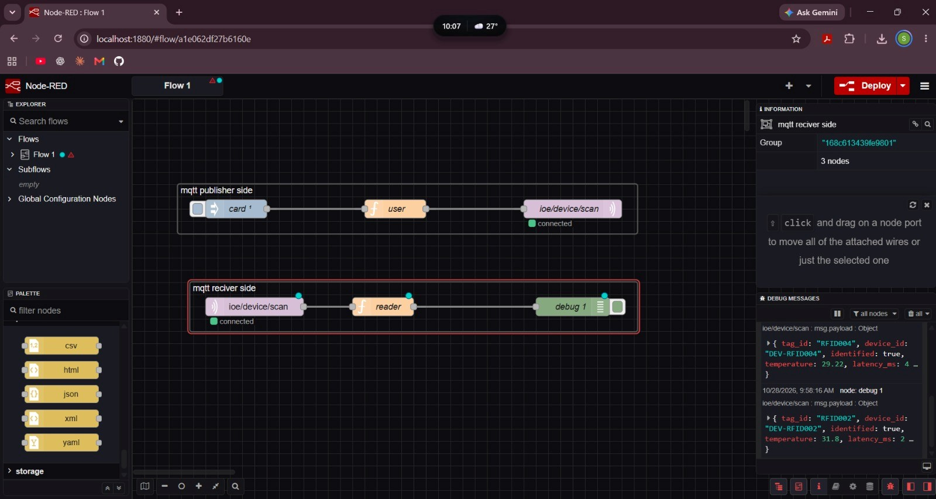
DEBUG CONSOLE OUTPUT & PERFORMANCE EVALUATION
Figure 2: End-to-end verification of MQTT publisher and subscriber groups showing verified telemetry
packets.
Tag ID | Device ID | Identification Status | Temperature (°C) | Latency (ms)
RFID004 | DEV-RFID004 | true (Authorized) | 26.26 °C / 29.22 °C | 2 – 4 ms
RFID002 | DEV-RFID002 | true (Authorized) | 31.80 °C | 2 ms
UNKNOWN999 | DEV-UNKNOWN999 | false (Unauthorized) | 25.20 °C | 9 ms

RESULT
The simulation of RFID/NFC-based device identification and IoE data integration using Node-RED and MQTT was successfully performed. Authorized devices were identified with minimal transmission latency (2–4 ms), while unauthorized tags were recognized and flagged appropriate

CO1 Simulation • Experiment 5(a) Lab Manual Page 2 of 2

